'You are standing on the surface of the Earth. You walk one mile south, one mile west, and one mile north. You end up exactly where you started. Where are you?'

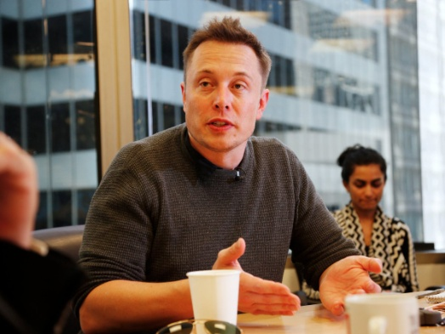

Elon MuskReuters/Stephen Lam

According to the biography "[Elon Musk: Tesla, SpaceX, and the Quest for a Fantastic Future](http://www.amazon.com/Elon-Musk-SpaceX-Fantastic-Future/dp/0062301233/)," the Tesla and SpaceX CEO likes to ask candidates this riddle to test their intelligence.

There are [multiple correct answers](http://www.businessinsider.com/elon-musk-favorite-interview-question-2016-1), and one is the North Pole.

'A hammer and a nail cost $1.10, and the hammer costs one dollar more than the nail. How much does the nail cost?'

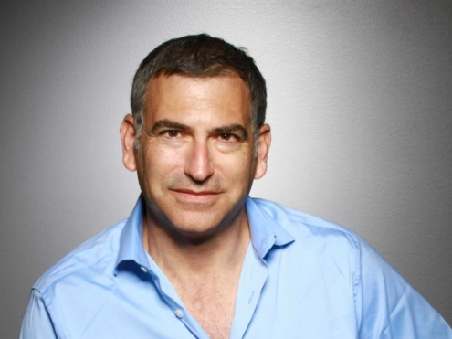

Jeff ZwellingCourtesy of Convertro

Jeff Zwelling, COO of job search engine ZipRecruiter, says he often turns to tricky questions during job interviews to get a better sense of who the candidate is.

For example, in the middle of the conversation, he often throws in this curveball math question.

"Some candidates will instantly blurt out 10 cents, which is obviously wrong," [he tells Business Insider](http://www.businessinsider.com/ceo-asks-candidates-this-trick-math-question-2014-5). "They don't have to get the exact right answer, which is a nickel, but I want to see them at least have a thought process behind it."

Zwelling says he understands that math isn't everyone's forte, but he wants them to realize that "10 cents is too easy of an answer, and that if it was that easy, I wouldn't be asking it."